**Procedures for How to Wear the Undershirt**

Thank you so much for participating in our study! You should have been given these items:

* 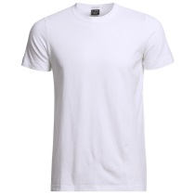White cotton t-shirt
* Unscented soap
* Unscented shampoo
* Ziplock freezer bag
* Unscented detergent

We are conducting a scientific experiment on smell. Your part is to wear the undershirt we gave you for 24 consecutive hours. For our results to be accurate there are a number of precautions we need you to take. They will ensure that the shirt doesn’t end up smelling like something we don’t want! It is ***vital*** for our experiment that you follow these rules:

Please return the worn shirt by: __________________

1. For 24 hours before wearing the shirt and while wearing the shirt:

* Avoid eating odor producing food including chili, garlic, pepper, vinegar, asparagus, spicy food, onions, pepperoni, strong cheese, cabbage, radish, celery, fermented milk products (such as yoghurt), marinated fish and lamb
* Avoid using deodorants, antiperspirants, aftershaves, perfumed soaps and shower gels
* Smoking, drinking alcohol and using drugs
* Sleep alone in your bed (no pets or other people)

2. Directly before wearing the shirt:

* Use the provided detergent to launder your bed sheets and towel and any clothes that will touch the shirt (especially the over-shirt).
* 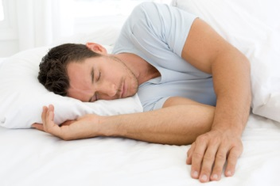Wash your body and hair with the provided soap

3. While wearing the shirt:

* Please wear another shirt/sweater over our shirt during the day. The shirt we give you should be worn as an **undershirt** to protect it from outside smells.
* Avoid smelly places such as bars
* Avoid excessive exercise and odor producing activities (including sexual activities)
* Continue the same procedures as you have for the past 24 hours, including avoiding certain foods and smoking, drinking and using drugs.

**Example scenario:** You decide to wear the shirt starting at 8am on Tuesday morning and ending at 8am on Wednesday morning:

Starting 8am Monday morning, you will avoid all of the activities listed in section 1 above (including not eating smelly foods, not smoking, not wearing deodorants, etc).

On Monday night, you will need to follow the instructions outlined in section 2 above. You will wash your bed sheets, towel and all of the clothes you will be wearing for Tuesday with the provided detergent. You will also need to take a shower and wash your hair with the provided soap and shampoo before getting into your clean bed.

On Tuesday morning before putting on the shirt you have the option to take a shower. For the next 24 hours (till Wednesday morning), you will continue to avoid all the activities in section 1 that you have been avoiding since Monday. In addition, you will do the things listed in section 3 above which include avoiding smelly locations and wearing the provided shirt as an undershirt while you are awake (you do not need to wear another shirt over the provided shirt while you are sleeping).

On Wednesday morning at 8am, take off the shirt and seal the undershirt in a ziplock bag and drop it off to us between 9-11am and then you are free to do as you wish!

Please help us by thinking of any other reasonable precautions to avoid contaminating the shirt or yourself with extraneous odors! If you spill something on the shirt, no problem! Just email to set up an appointment to come by and get a new shirt.

While not wearing the shirt, store it in the sealed ziplock bag. At least 24 hours before study completion, email us to schedule the drop off appointment (we need the shirt the morning of study completion).

If you have questions, just email us at [chenlabstudy@gmail.com](mailto:chenlabstudy@gmail.com)

Goodbye for now!

